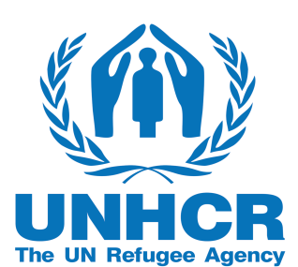
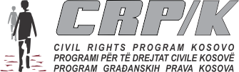

NOTICE FOR LAWYERS’ APPLICATION FOR PARTICIPATION IN
TRAINING ON THE INTERNATIONAL REFUGEE PROTECTION

Kosovo Bar Association, in cooperation with the UNHCR and the Civil Rights Program in Kosovo (CRP/K), organizes a one-day training on international refugee protection. The training will be organized within the cooperation agreement between the Kosovo Bar Association and UNHCR.
All interested lawyers are invited to apply. Please be reminded that due to the limited number of 30 participants, the following applicants will have priority in the selection:
- Lawyers with over 2 years of work experience;
- Lawyers who have been engaged in the area of human rights, (i.e. the asylum seekers and refugees’ rights);
- Lawyers who have participated in previous trainings in the area of asylum seekers and refugees’ rights;
- Knowledge of English is mandatory;

The application will be made via e-mail to: Training Center for Lawyers qendratrajnuese@gmail.com by 15 November 2022 at 16:00hrs.
The gender equality principle will be taken into account during the selection process.
The selection will be done by the joint team from KBA, UNHCR and CRPK.
The selected lawyers will be considered for future training in the area of International Refugee Protection.

The training will be held on 19 November 2022.

